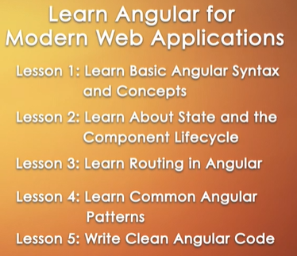





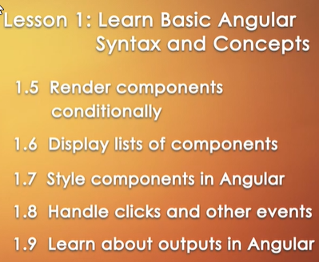





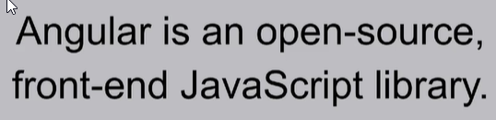









Angular: Framework, React: Library

Angular: right way to do a thing, React: Many ways to do same thing.



Much easier to transfer over gradually and used in case of existing web apps. Angular used when want to build from scratch.



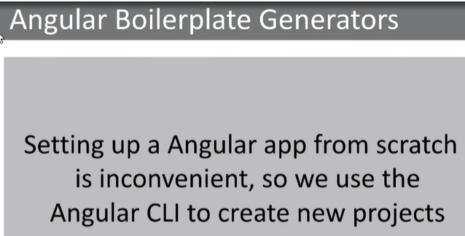

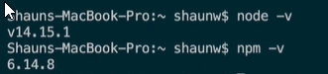

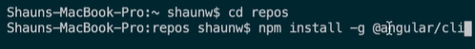

npm install -g @angular/cli









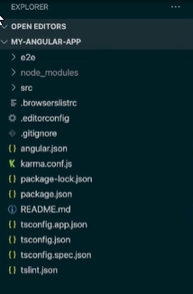

Setup done, Check version of node, npm, install angular cli, ng new my-angular-app, code. to launch vs code



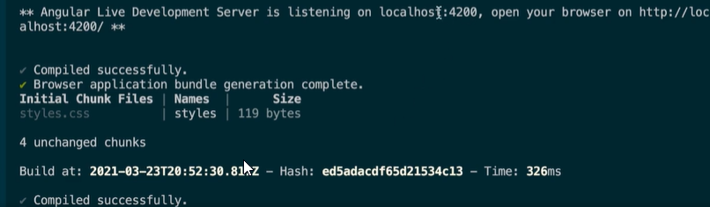

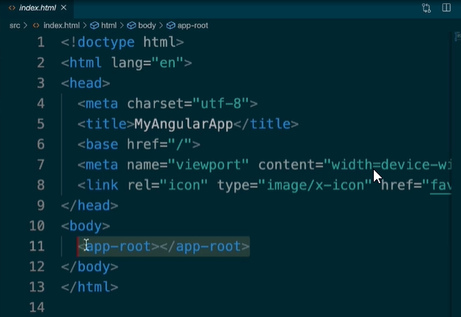

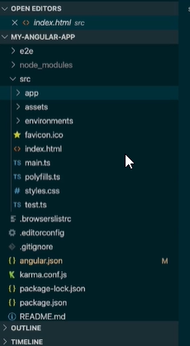

The whole app component is rendered inside the app-root tag inside index.html.

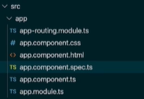

spec.ts: contains the tests for our components

routing.module.ts file: contains routing logic for our file



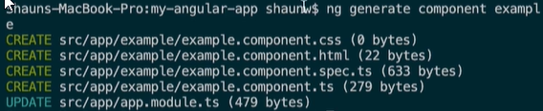

app.component delete all boilerplate code but keep the router-outlet, and paste the app-example.

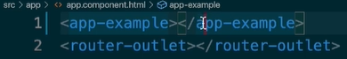



ng serve -o; opens automatically in a browser.

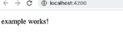

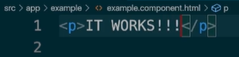

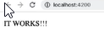

Hot reloading, automatically updates.

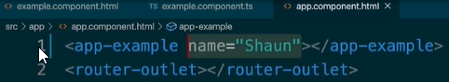

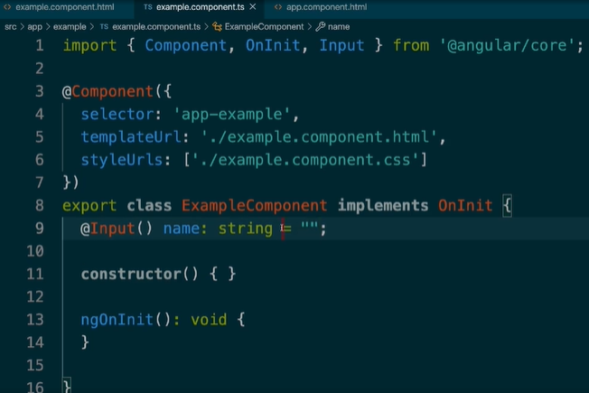How inputs/ Passing inputs to components look like.

Import Input in example.component.ts file, add 9th line

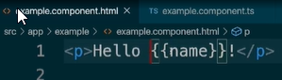

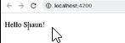

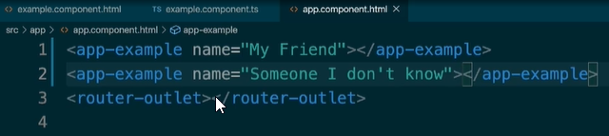

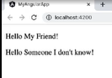



To hide certain components where we need to, we something called Structural- Directives in Angular.

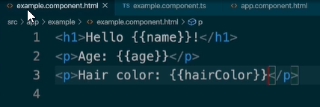

Display few attributes inside example.component.html

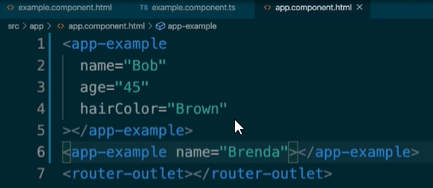

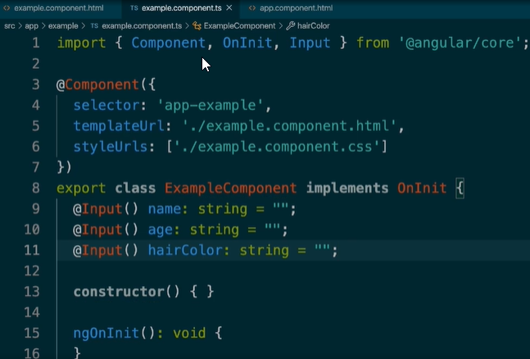

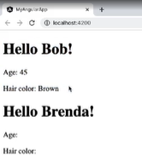

If we want to hide certain components like age or hair color if we did not pass any input for those,

We use structural directives, \*ngIf

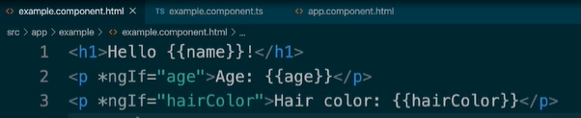

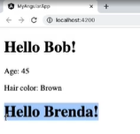

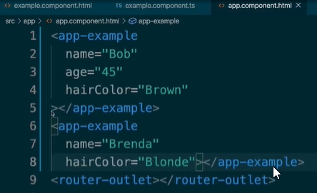

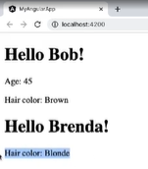

What if, no name is given, we just want to display Hello.

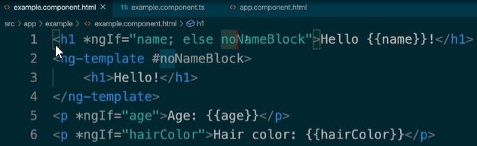

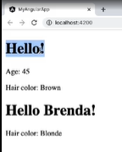If name exists display first element, else display noNameBlock template.

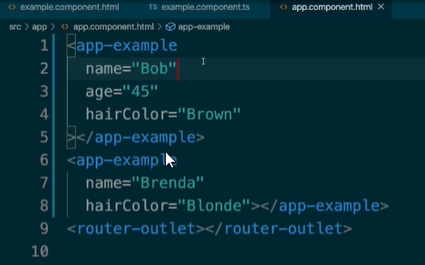

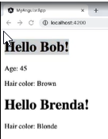

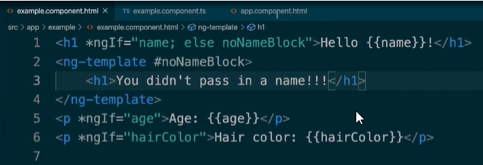



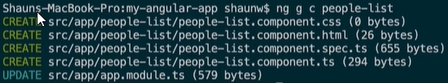If want to display a list of elements on the screen.

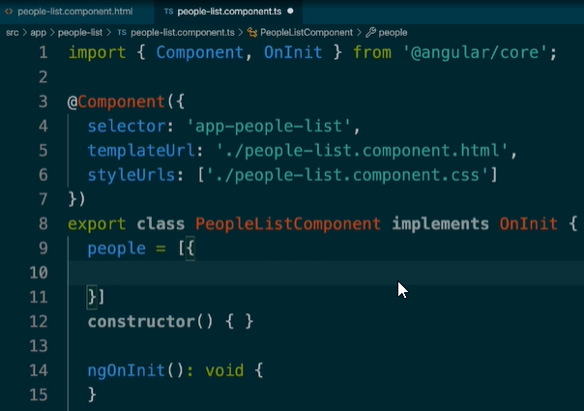Generates new component called people-list

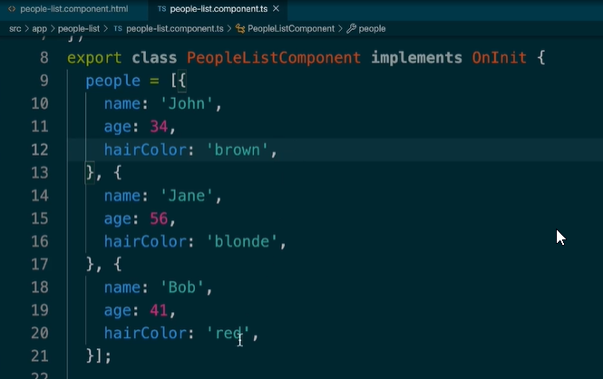

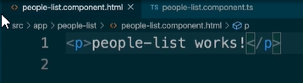

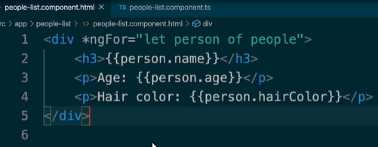

For each loop, using \*ngFor= “let person of people”

So now, we go to our app.component and display our people-list.component

Tag we get from the selector in ts file of people list component.

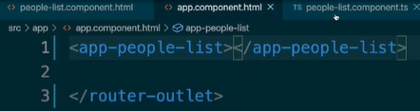

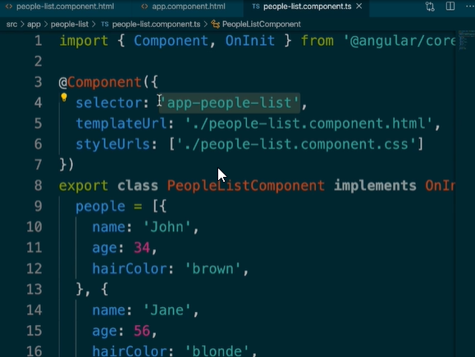



Restart using ng s, or ng start.

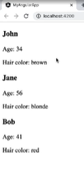

\*ngIf and \*ngFor cannot be used in the same line together.

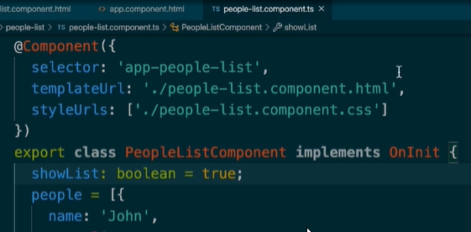



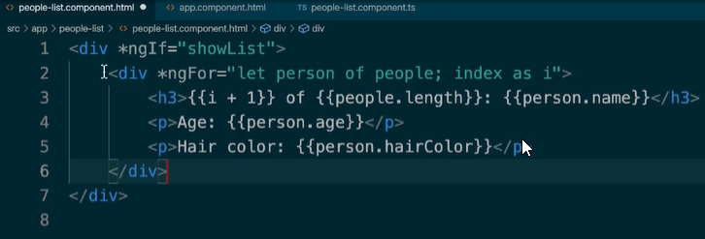

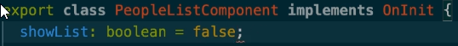

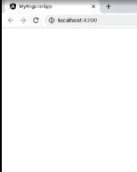

Boolean false hides our list, using ngif and ngfor nested and people list component.ts



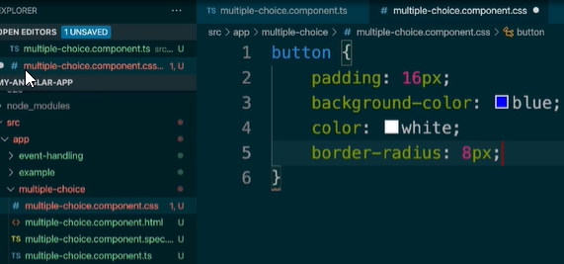

In a new component.

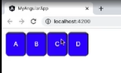

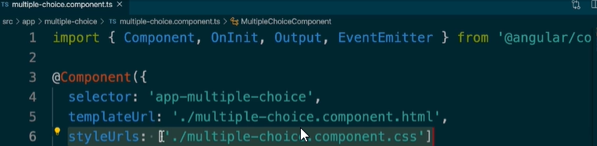

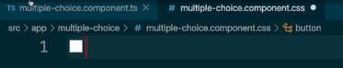

Remove styles

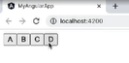

Styling goes back to normal.

Component specific styling, only apply to the specific DOM/component, if this css code is put inside app.component.css, styles will not show up, even though the multiple choice component is inside app component.

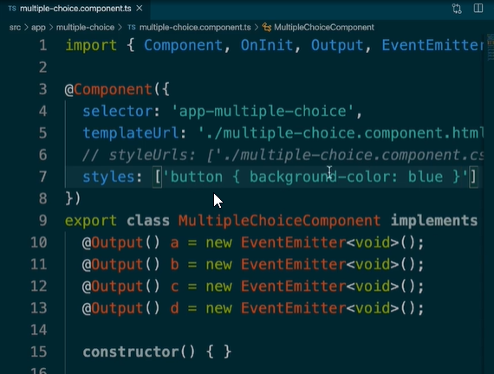

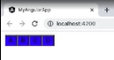Another way to define styles is inside our component decorator.

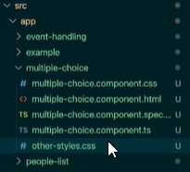In styleUrls, we can pass multiple file paths to it, if we want styles from several css files to be sort of combined.

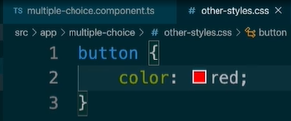

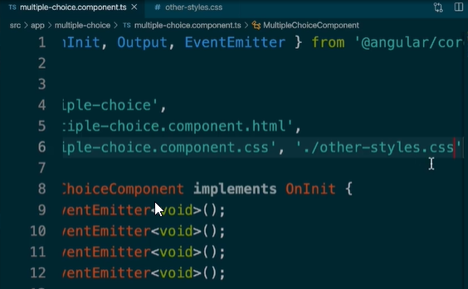

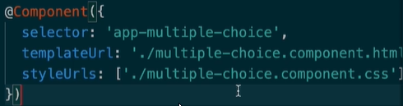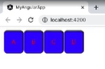





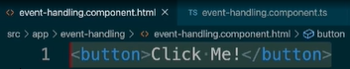

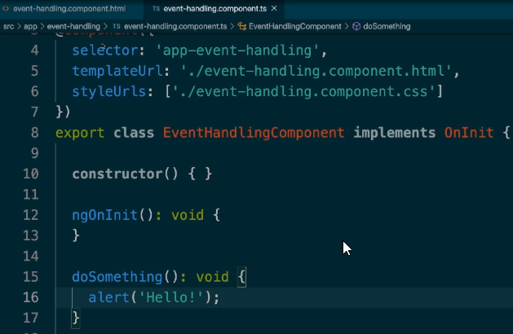

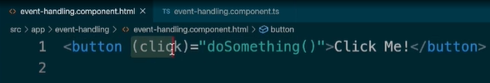Call the doSomething method, on click of the created button.

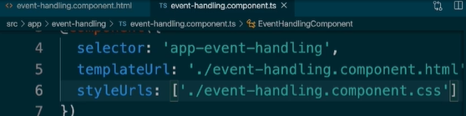

Open app.component and display the app-event-handling component inside.

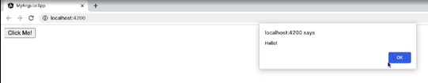

Obviously you can have multiple methods inside the EventHandlingComponent .ts file.

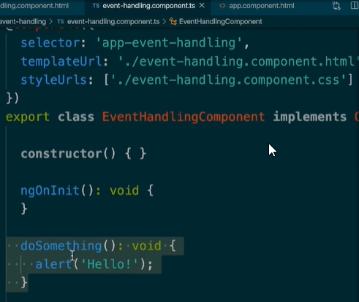

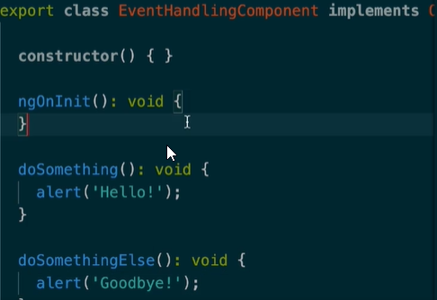

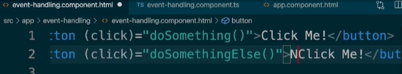

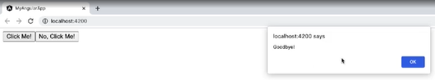

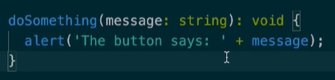

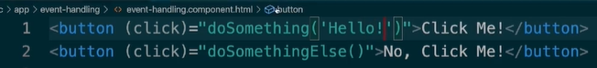

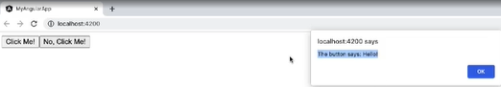

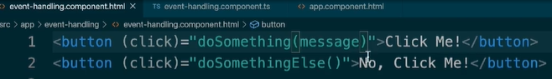

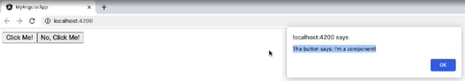

Basics behind basic event handling in Angular.

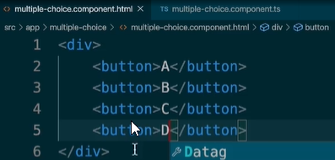

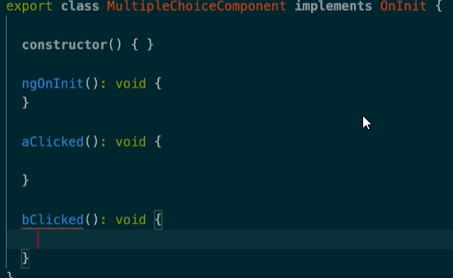

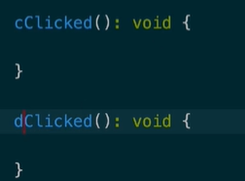In multiple-choice.component.ts

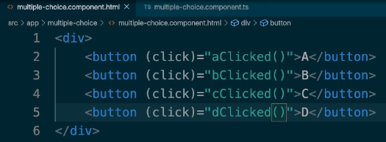

<button (click)=”aClicked()”>A</button>

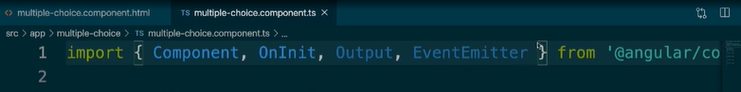

Import Output and Event Emitter.



In class inside .ts.

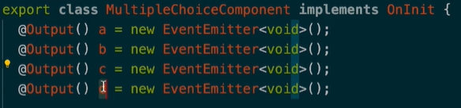

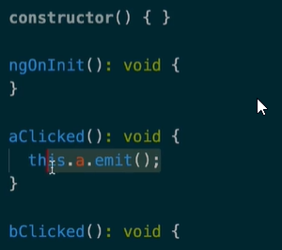

.emit() for all of the events.

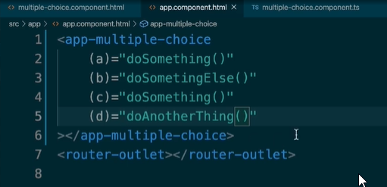

In app.component.html

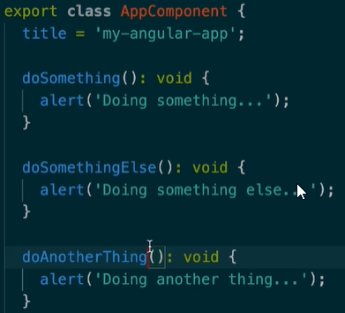

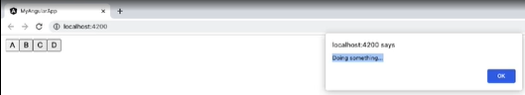

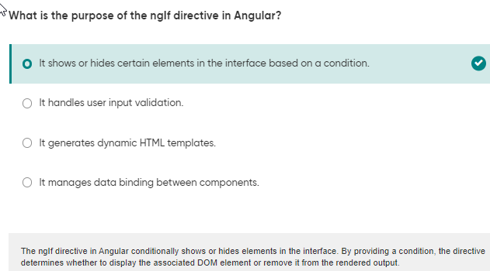

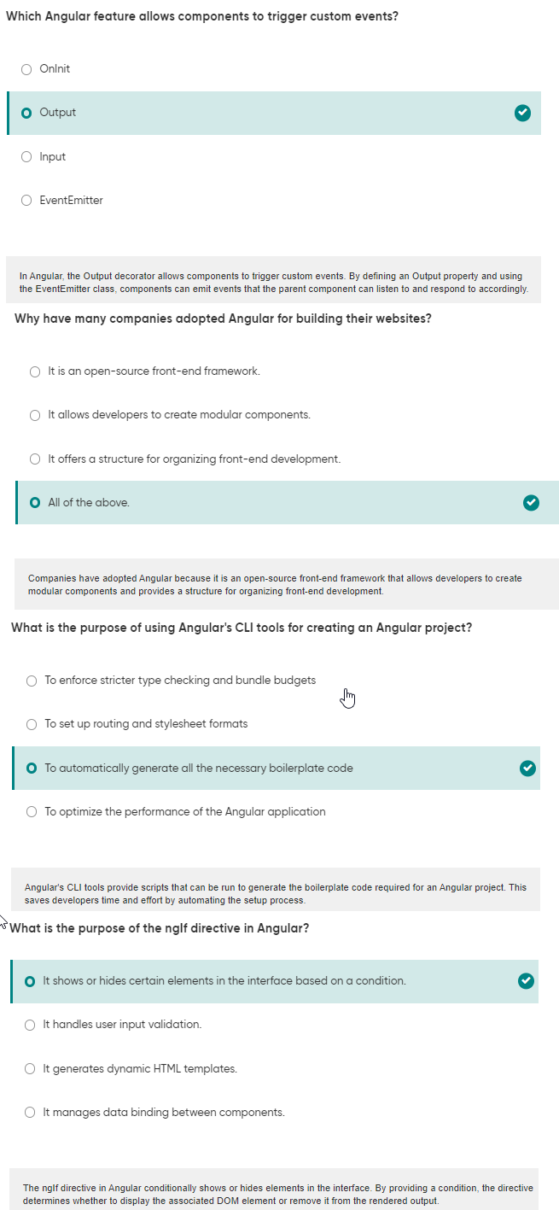







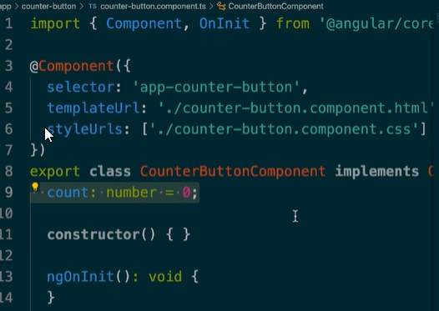

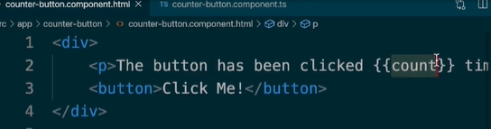

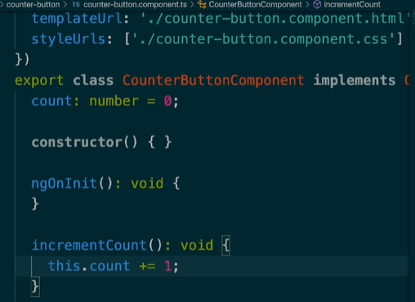

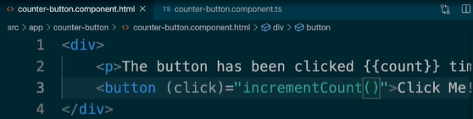

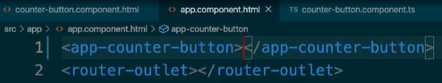

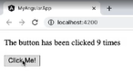Add in app.component.html

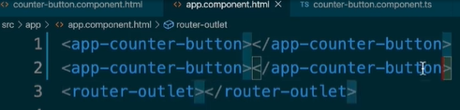

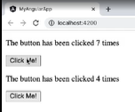



When certain number of times button has been clicked, want to show a specific message, in component outside the counter-button component.

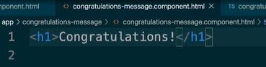

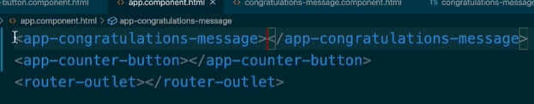

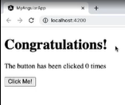

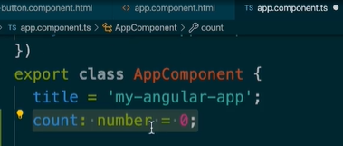

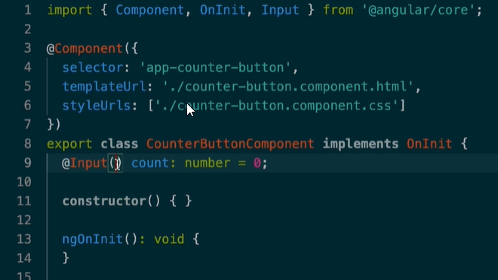Add count variable in AppComponent.ts

Import Input in cb component deleting other methods.

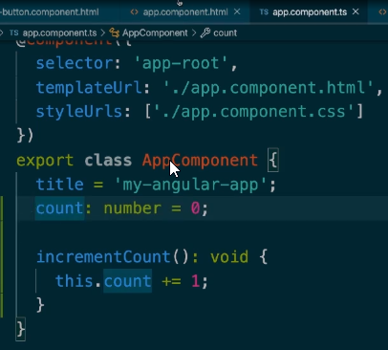Default value of number is 0.

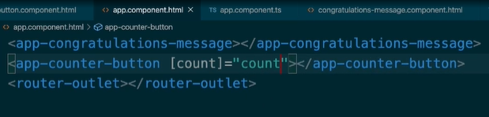

This is how we pass non numeric values as inputs.

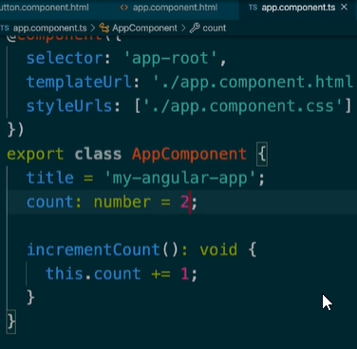

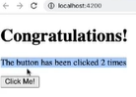

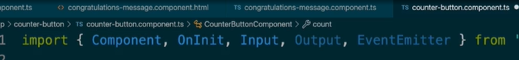

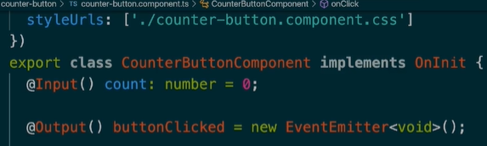Cb component, import both output and eventemitter.

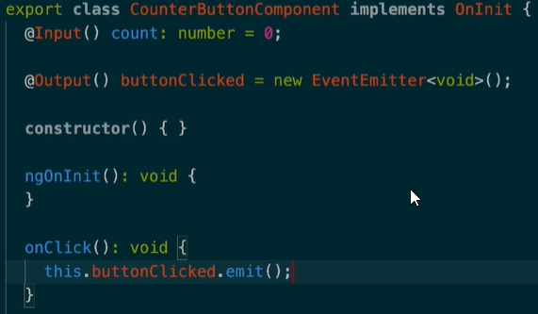

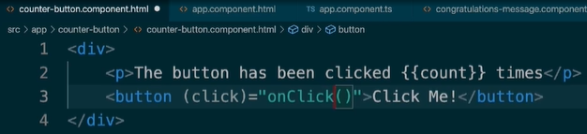Create a new event buttonClicked.

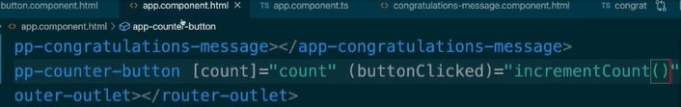Change function from onIncrement to onClick which triggers event buttonClicked.emit.

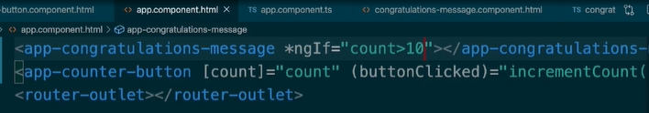

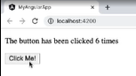

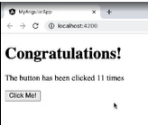

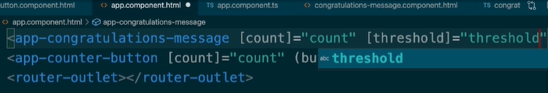

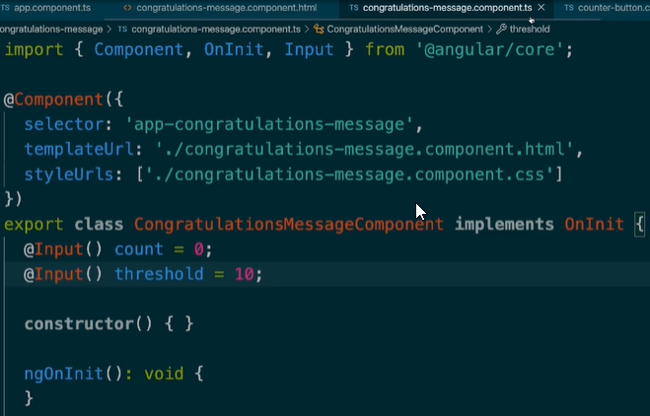

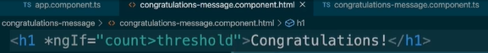

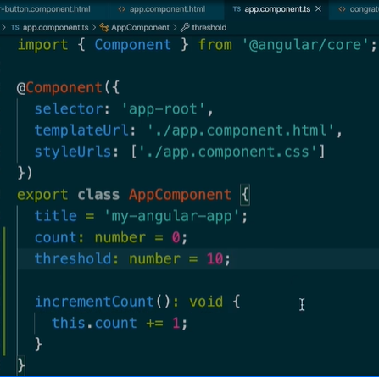

Appcomponent passes down its state for count and threshold both to congratulations-message and counter-button component.

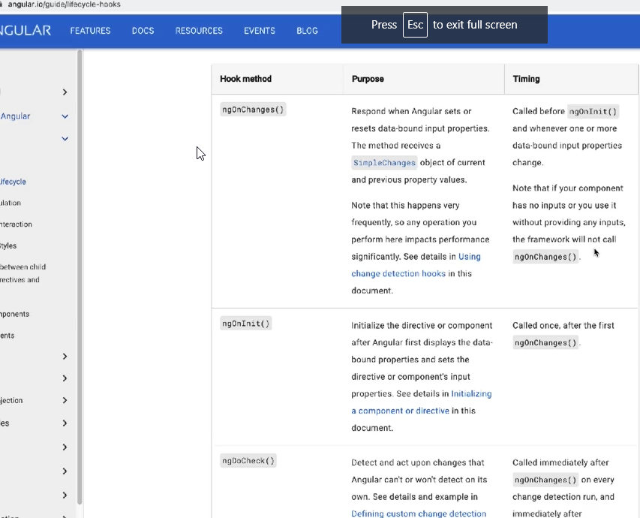

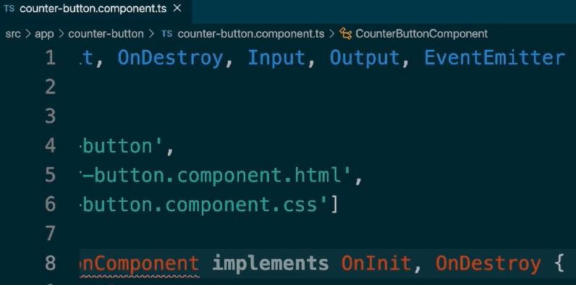

Import OnDestroy and implement the interface in counter-button.component.ts

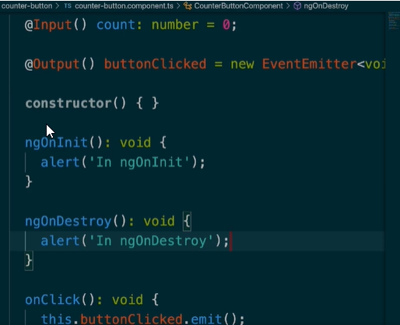

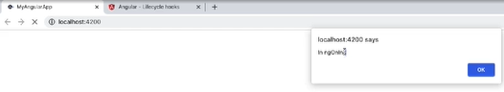

Lifecycle Events in components.

ngOnDestroy: To occur, One way: If you are using a router and you are using a different route.

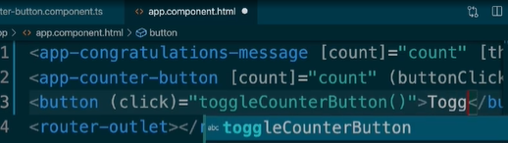Add a button to hide/show our counter button component.

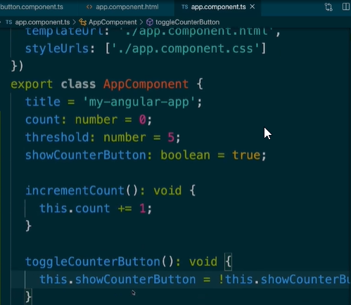

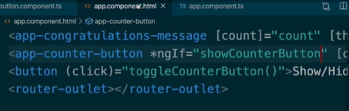Toggle Counter Button: variable and function in app.component.ts

ngOnInit(): Load data initially on load, like network requests.

ngOnDestroy(): Cancel any intervals/timeouts/subscriptions that we have, to avoid any memory leaks after the component that was using those things has been destroyed.

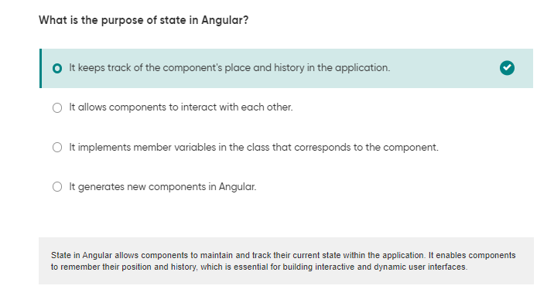Mostly these two are used, Other functions are not used enough.

V

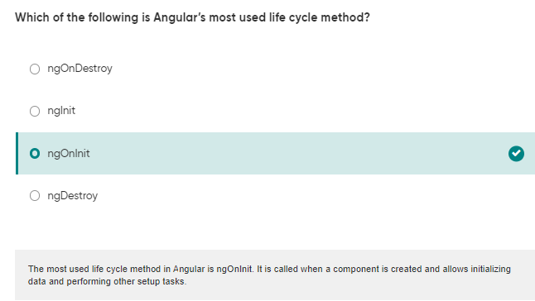

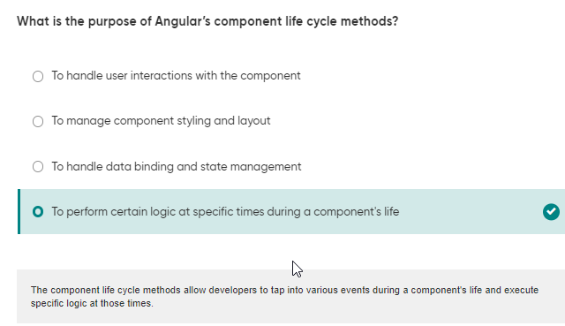

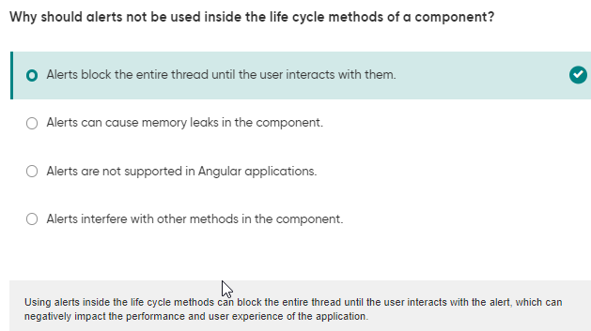

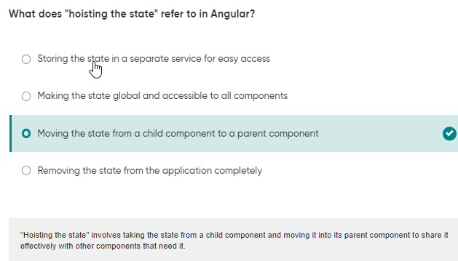

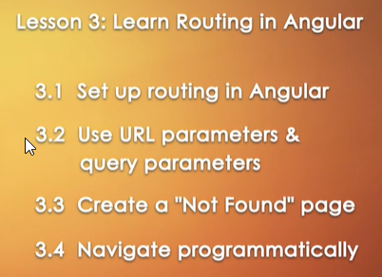



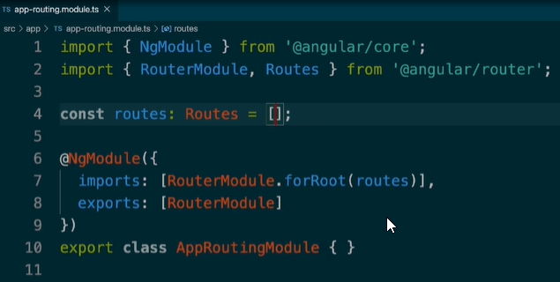

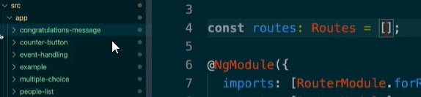app-routing.module.ts

Create a route for each of these components inside the Routes array.

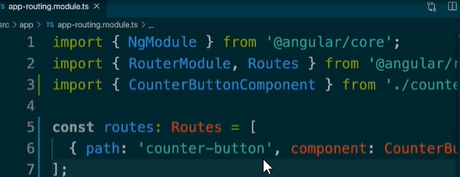Import the components, set the path(extended url, and the component name).



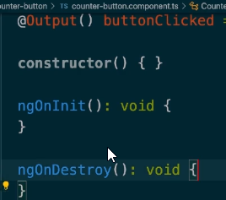

Remove the alerts on ngoninit and destroy in cbcomponents class.

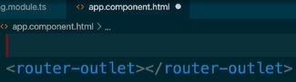Except for router-outlet delete everything in app.component.html file.

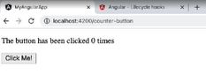

Not working now.

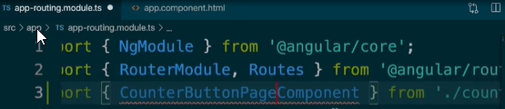



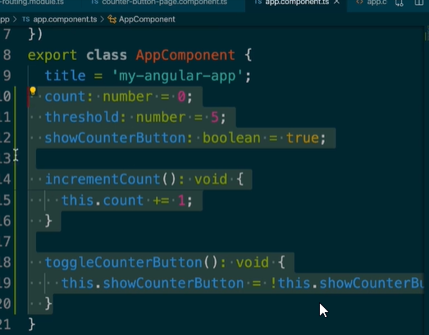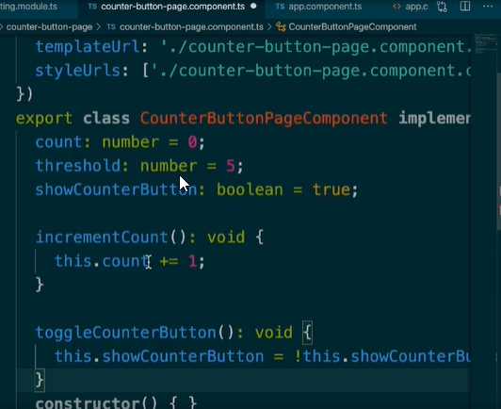

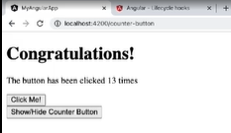Cut and paste from app.component.ts to counter-button-page.component.ts

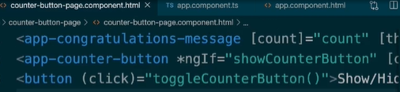

Cut paste from app.component.html to counter-button-page.component.html

Works

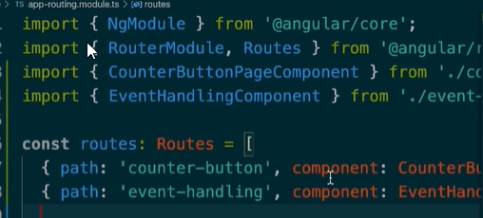

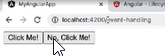

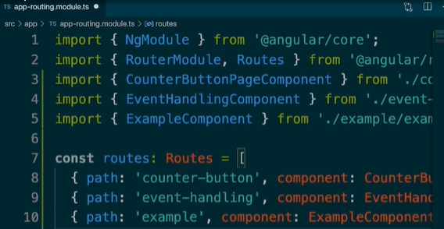Do the same for Event Handling Component

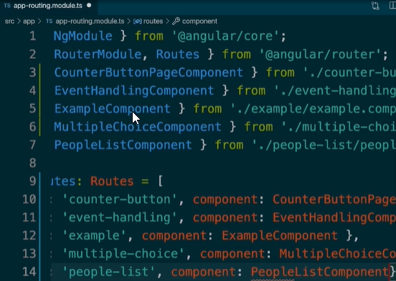

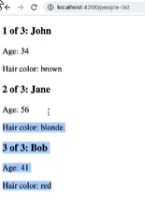

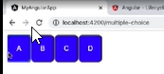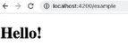Do for all Components.

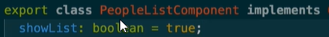

Want to create different pages, people, contacts, create components, add routes,

Add home route

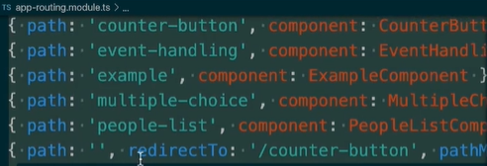

Add a home route and pathmatch: full,







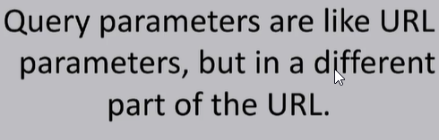

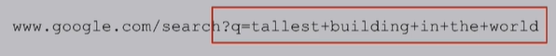

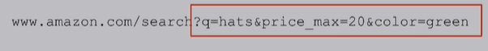

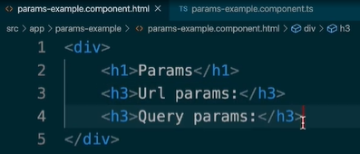 

Want

Add path to Routes array in routing.ts

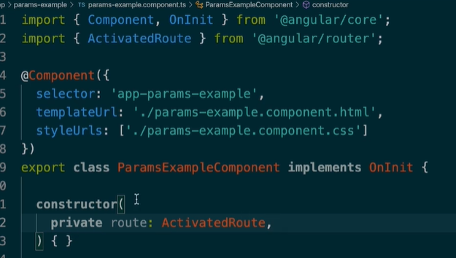: signifies url parameter

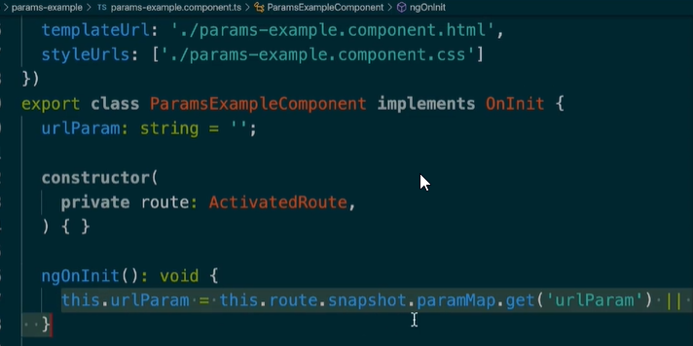Import Activated route in new c and pass into constructor as argument in ts file

Declare urlParam and initialize it in ngoninit.

Add a route member variable to our component that we can use to do things like getValue.

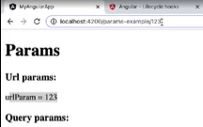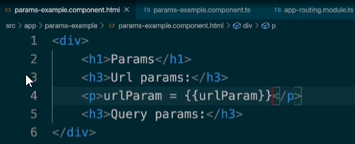

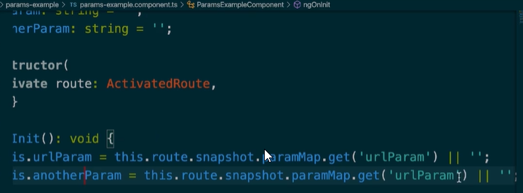Parsing the value of that url and inserting in urlParam.

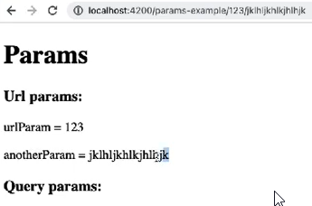We can do the same thing for another parameter. variable declare and nginit get

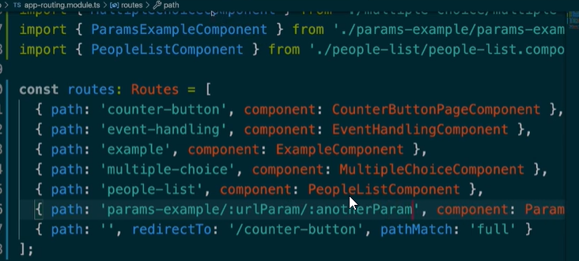

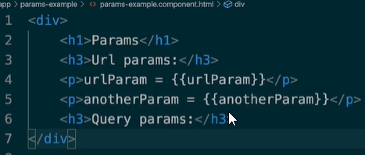This is how we get URL Parameters. Now we will see how to get query parameters.

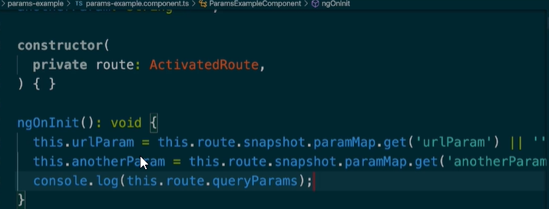

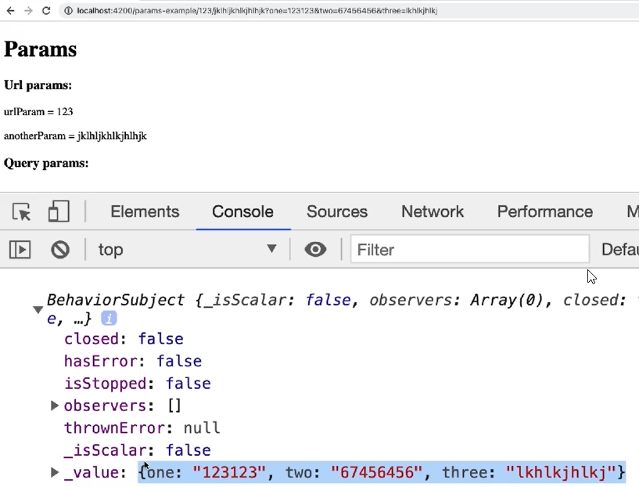

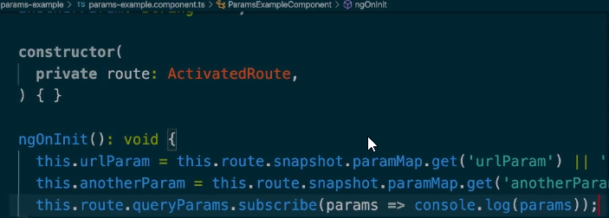console.log(this.route.queryParams);

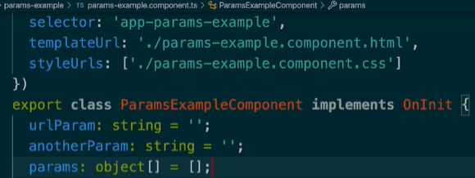.subscribe thing updates the parameter instantly, no need to refresh the page.

Declare the params object variable;



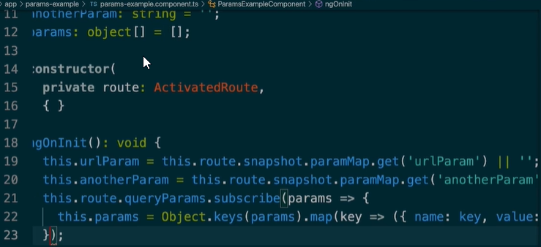

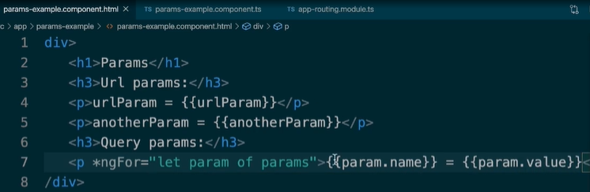

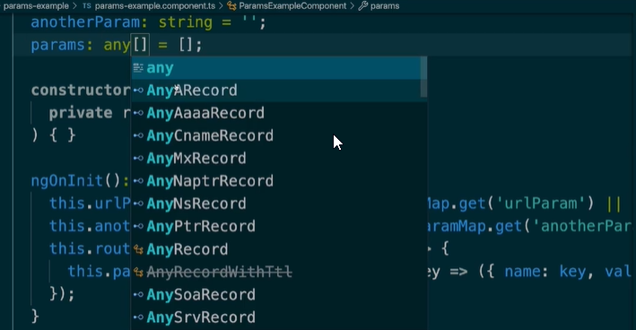

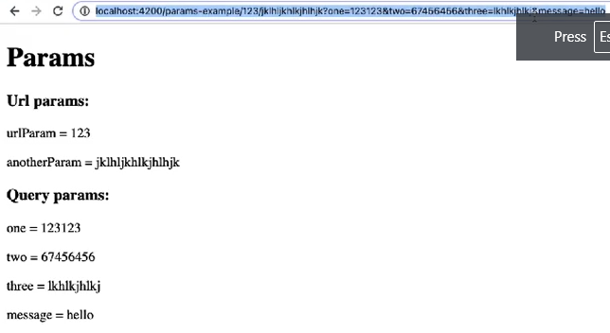Change type of param to any[].

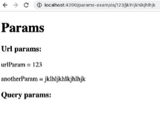

Delete all and we won’t have any.



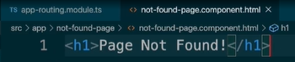ng g c NotFoundPageComponent



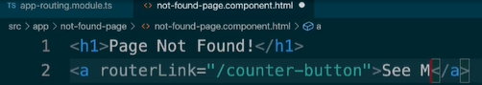

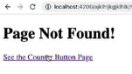routerLink for hyperlinks to different components.

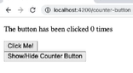

Click and send the user to the counter button page.

If we use href, it actually reloads the page, which can have a significant effect on performance, so we use routerLink.

Another way to navigate is programmatically, by using functions inside of our components.

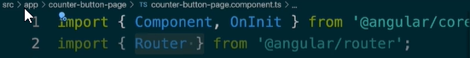

Import router from the ‘@angular/router’ package.

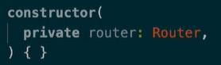

If (this.count > this.threshold) navigate programmatically to another page.

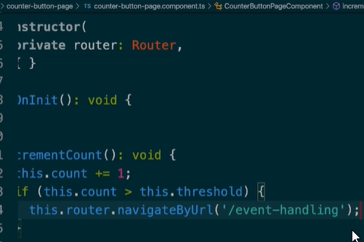

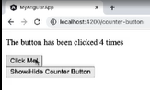To the event handling page from the counter button page.

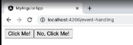

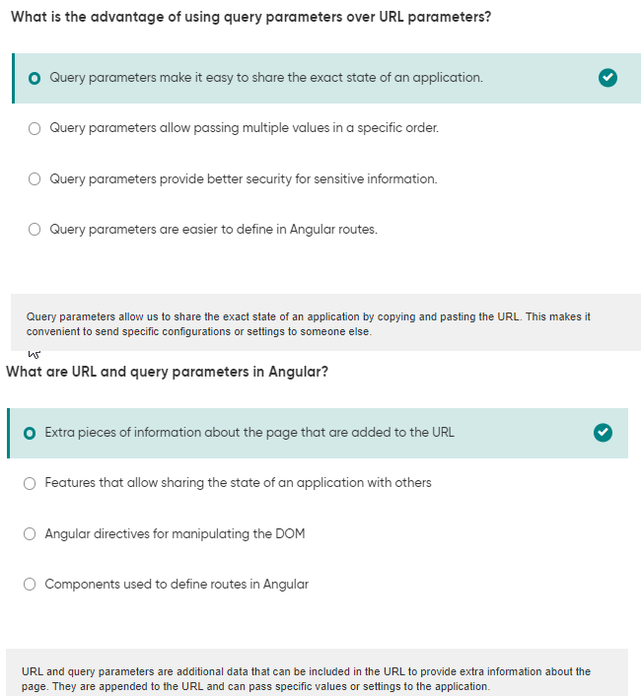

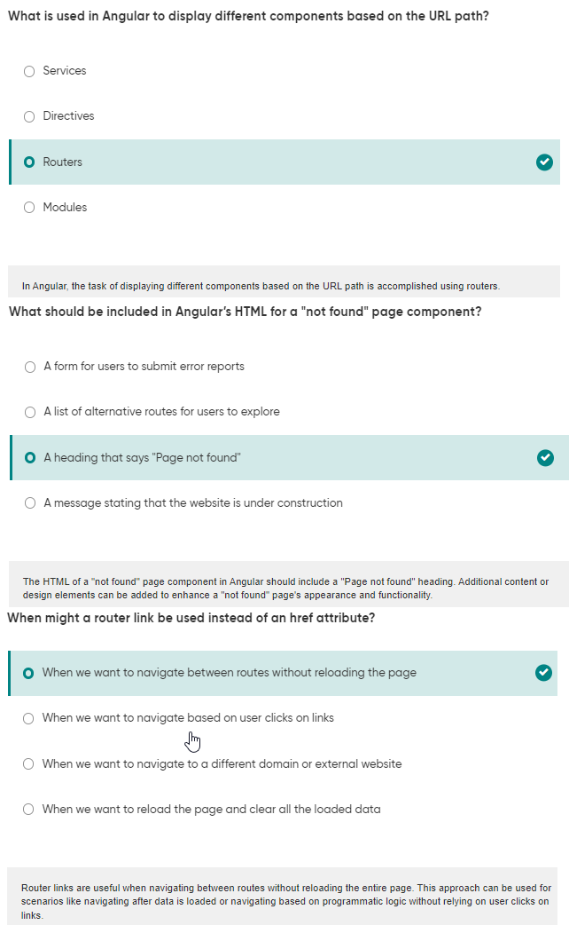

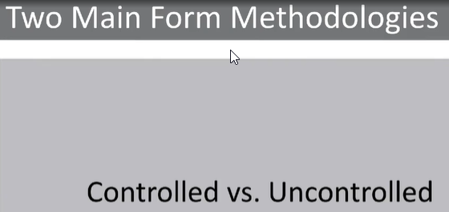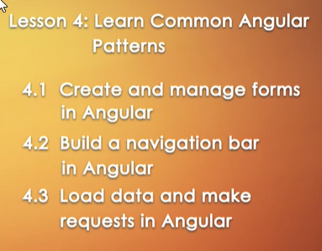

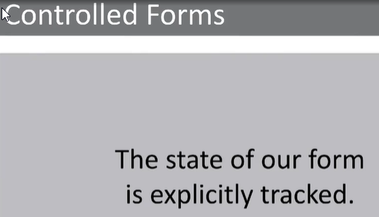







In approuting.ts

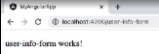

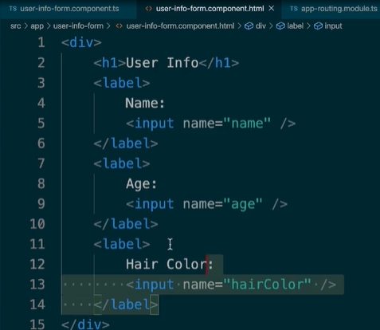Test: Boilerplate for our user info form.

Provide inputs, inside div, label, input.

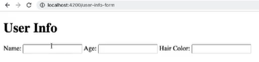

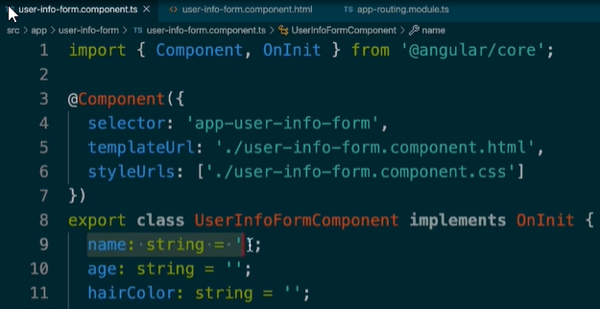

Add the form variables in the .ts file of the new form component.

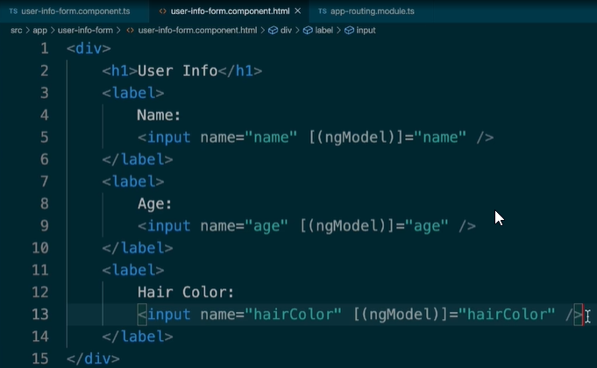Forms Module: When we have a form with inputs taken in .html file and corresponding member variables, it allows a 2 way binding between the things, with ngModel

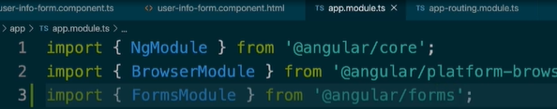Variable name should be one of member variables.

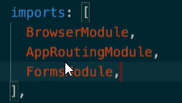

We have to import forms module in app.module.ts.

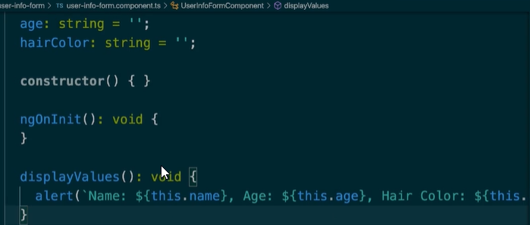Add the line to the .html file of the form component.



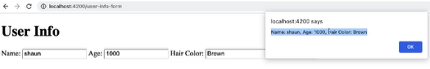Add parenthesis.

This allows us to do things like Form Validation, it also allows us to modify and process the data so that we can send it to a server of some kind.



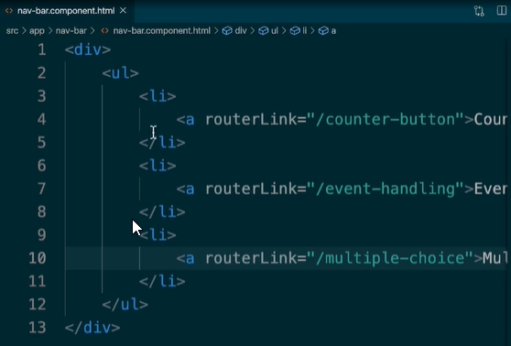Nav Bar Component

Add the components in a list in the nav bar component, with routerLink.

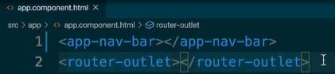

Add the app-nav-bar component in app.component.html so that will display all the different routes defined.

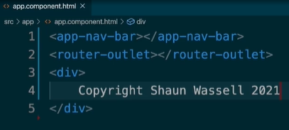

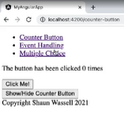

Working

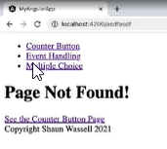

Even if we are in the not found page route the nav bar and footer will continue to show up.

If defined in app component, it will show up no matter what in the application.







In routing-module.ts

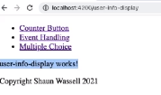



Generate service

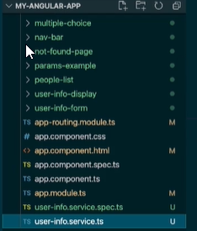

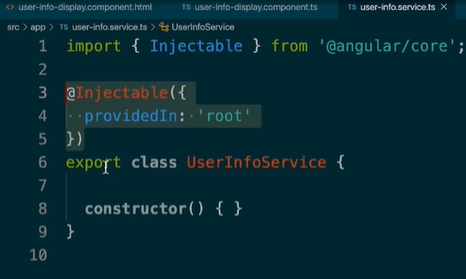2 user info service files generated directly inside the app directory.

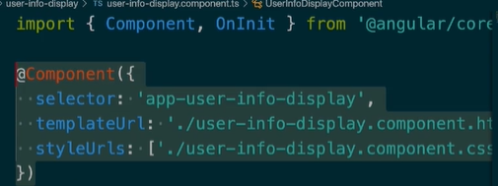

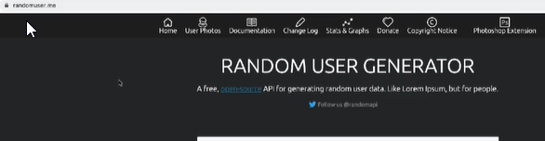Displays injectable, means our service can be injected into any of our components, as opposed to,

API: randomuser.me

Services make loading data reusable.

To load data from the api, we need one more piece, rxjs and HTTPClient.

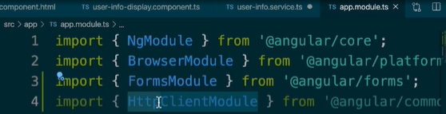

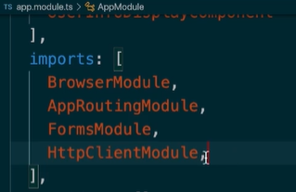Import httpclientmodule in app.module.ts

Add it to the imports list

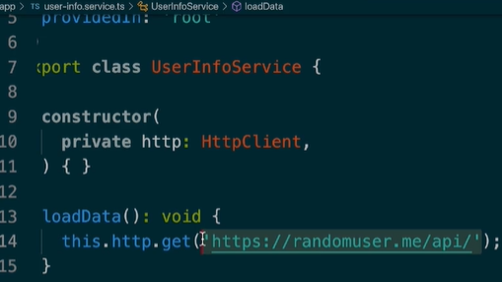

Declare the private http(HttpClient) and define in userInfoService the this.http.get() function.

Normally we would think of return, but things in angular like long running tasks are not done synchronously.

We have to subscribe to the event.

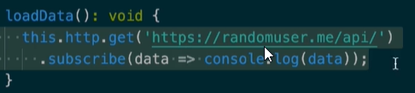.get() method returns something called observable

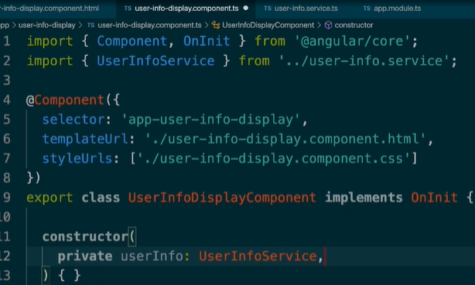

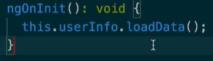

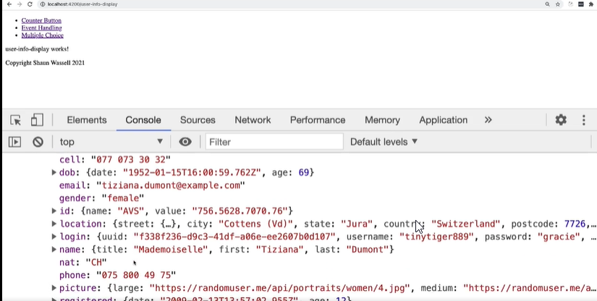In user info display.ts import the service, and declare in constructor.

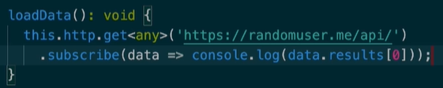The user data which we display in console.

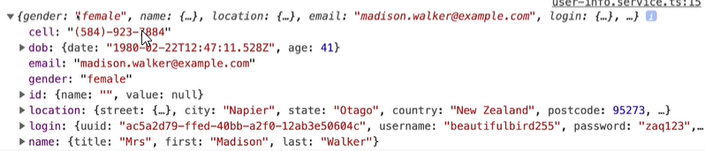

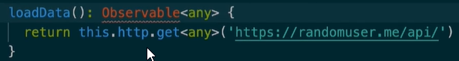

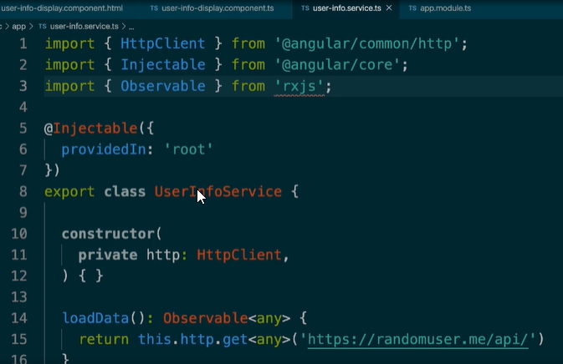

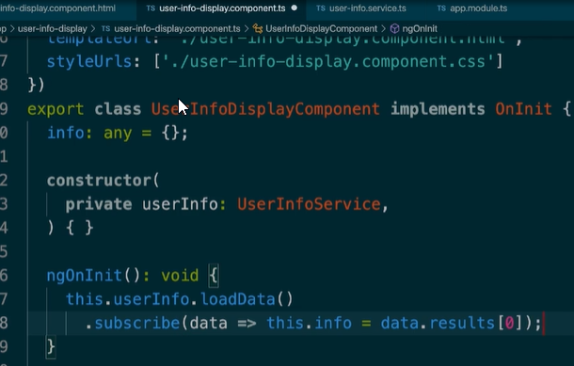Import observable from rxjs.

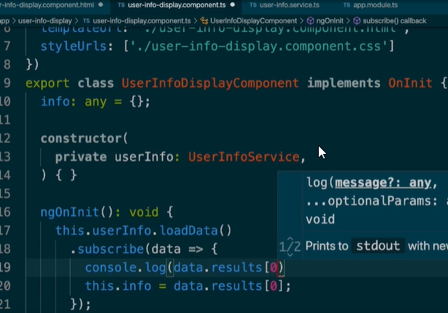

We capture the results from api from userinfo.ts file call in info variable.

Subscribe in component.ts in nginit.

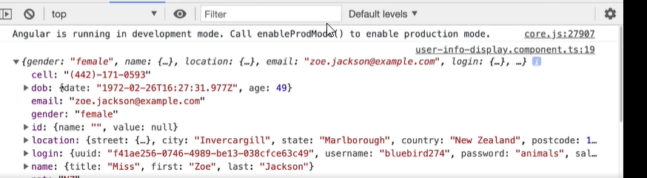Service.ts: load libraries and call the loadData function.

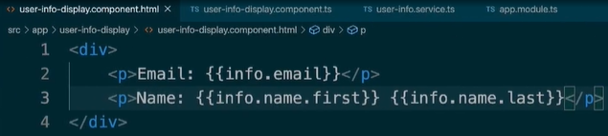

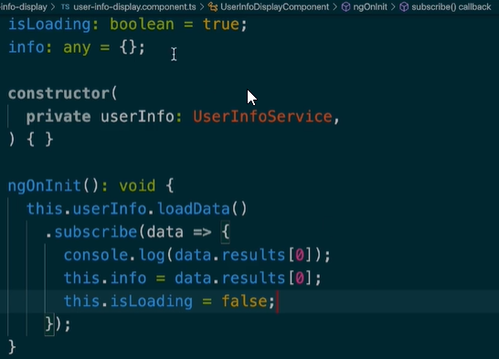

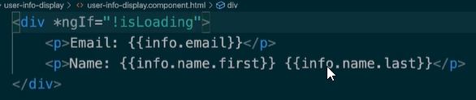

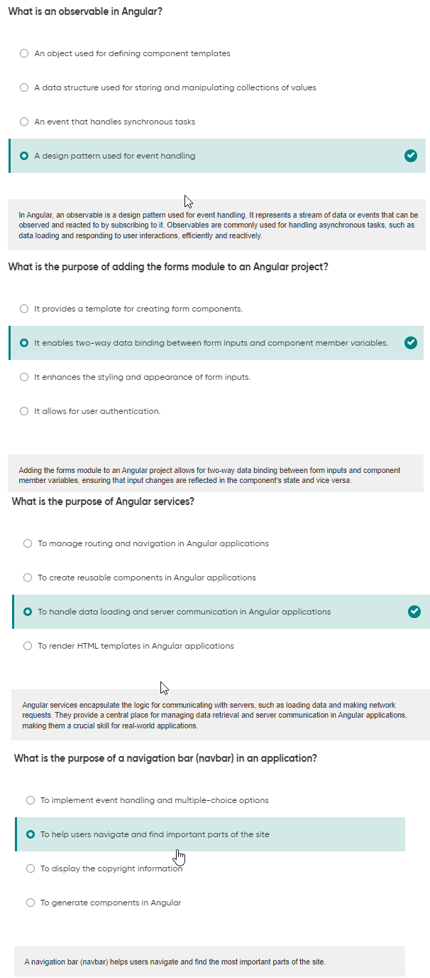

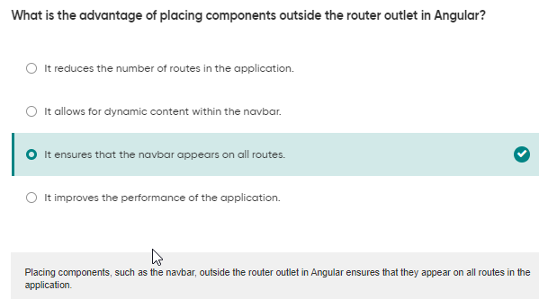





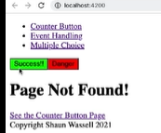

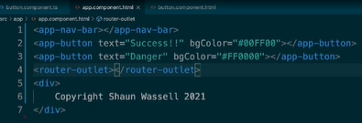

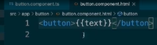

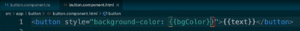



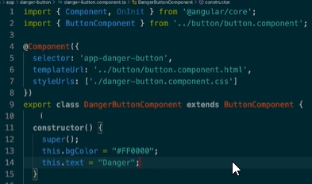Inheritance: extends button component

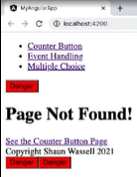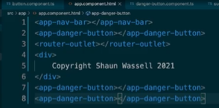

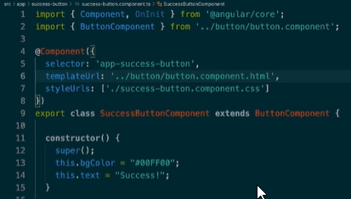

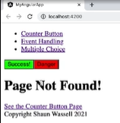

Now use composition for our components.

